Home Sensors Obstacle Slotted Optical Switch - MOC7811
Top of Form
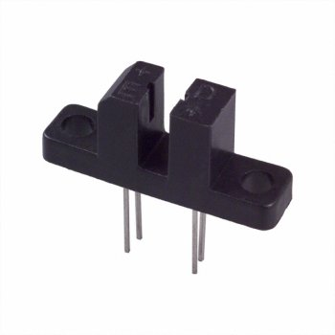  larger image | Slotted Optical Switch - MOC7811  Downloads  Ask a question about this product
  Price: Rs.28/- |  | Quantity: | 
  Model: | 3565
  Quantity Pricing:
    Quantity | Price | Discount
    5-9 | Rs.27/- each | 5% off
    10-99 | Rs.25/- each | 10% off
    100+ | Rs.22/- each | 20% off
  Availability: | In stock (Ships in 1 days)
  Data Sheet |  | (46.36 KB)

Details
MOC7811 is a slotted Opto isolator module, with an IR transmitter & a photodiode mounted on it. Performs Non-Contact Object Sensing. This is normally used as positional sensor switch (limit switch) or as Position Encoder sensors used to find position of the wheel. It consists of IR LED and Photodiode mounted facing each other enclosed in plastic body.

Specifications
- Size: Refer to the image below
- Mounting hole diameter: 3mm
- Mounting hole spacing: 19mm
- Slot width: 3mm
- Slot depth: 7mm

Applications
- DC motor position / velocity control
- Position and velocity servomechanisms
- Factory automation robots
- Numerically controlled machinery
- Computer printers and plotters

Details
When light emited by the IR LED is blocked because of alternating slots of the encoder disc logic level of the photo diode changes. This change in the logic level can be sensed by the microcontroller or by discrete hardware. This sensor is used to give position feedback to the robot or as Limit switches.
